Add Telangana Logo on left side of the page

College Name In middle of the page Right side Mjp logo

Under MJPTWRDegree College logo

Add “Learn to Lead”

Right side of the MJP logo

Add Visitors counts(how many members are visited these website)

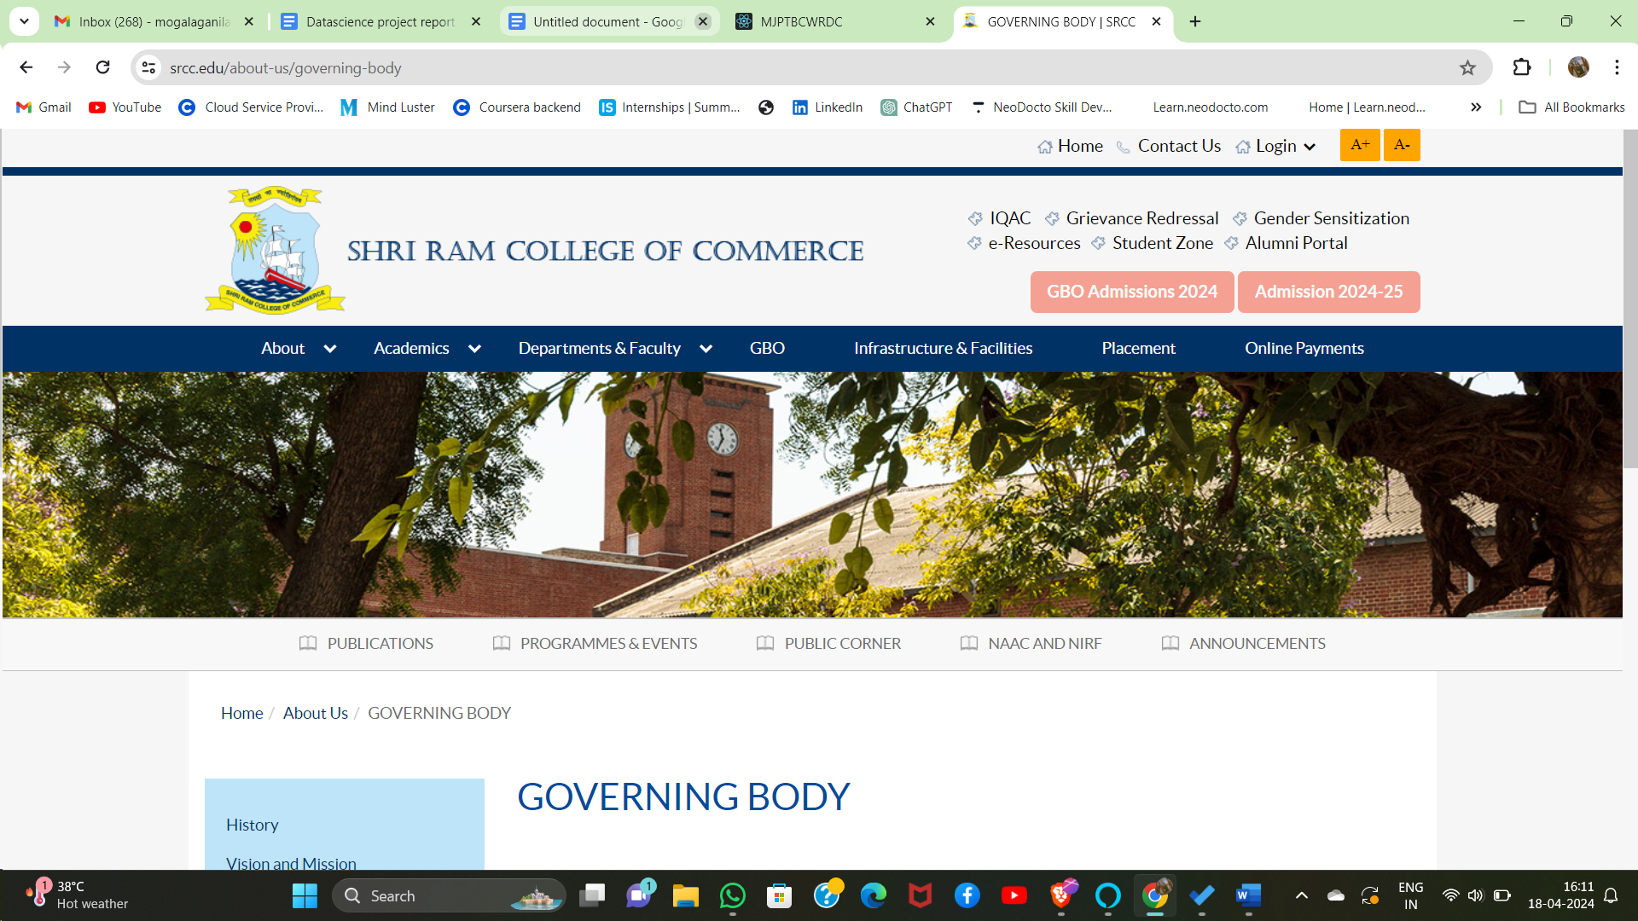

In home

tags [home, about, academics,Admission process**,** department and faculty, placement, Benefits of MJPT, MOU,IQAC)]

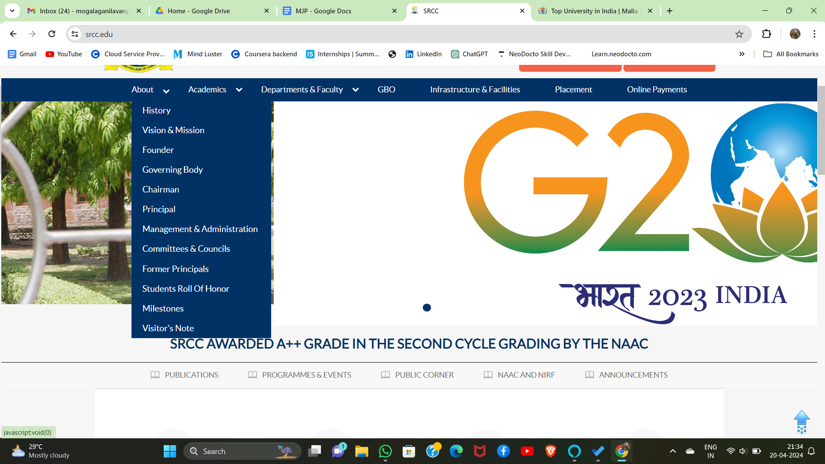

In **about**

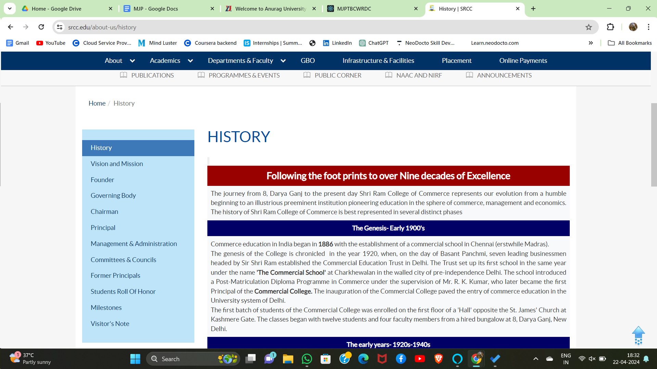

(All pictures should be close and open mode like above picture)

1.History(college picture, when we click on it we should get information about college)

2.Governing body(don't keep governing bodies.keep Governing body.)

3.Secretary (Add picture of Saidulu sir ,when we have click that picture we should get about Saidulu sir message for college in 1 page) ( make like this <https://www.srcc.edu/about-us/principa>l)(The message is available in MJP folder)

4.Principal (same as Saidulu sir ,about Bhaskar Rao in 1 page, replace principal sir picture with new picture)

5.vice Principal (same as Saidulu sir, about Govinda Rao in 1 page)

6.Management & Administration (only Madam’s name and departments) (<https://www.srcc.edu/about-us/management-administration>)

7.former principals(keep it same)

8.Visitor’s note (picture, when we put curse on image we should see they notes)

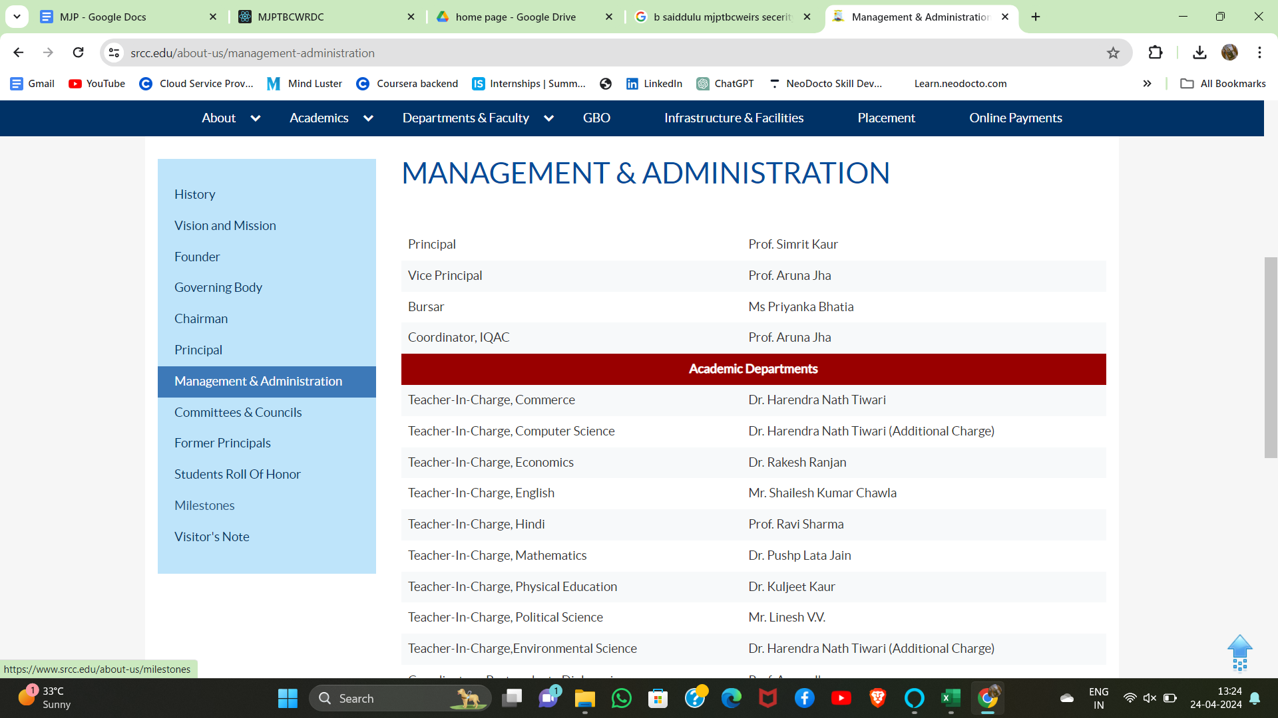

Replace In Managements & Administration (madam’s names & they departments)

In **Academics**

1.Research(madam’s research information, only topic name of there research paper)

2. Examinations details

In **Admission process** ([refer Malla reddy website](https://www.mallareddyuniversity.ac.in/), in that programmes offered )

1.courses detail (picture of courses , when we click on it we should get full details of course)

2. Sanctioned Eligibility criteria (refer Handbook in MJP Folder for sanctioned eligibility)



When we pointed on the picture of any courses it should be zoom in

School of engineering ( science groups i.e. MPCs,MSCs, MSDs)

School of agricultural ( groups i.e. BBC,BZC)

School of commerce & Arts ( group i.e. BA(HEP & HPML), B.com( general), B.com (computers), B.com(Business analytics)

3. No. of seats are available in particular courses.



In **Department & faculty**



Brief details about each and every madam(replace Neelima with any faculty name next line which department,next about they research and at last they full detail)

Same for every faculty, only change background color for one by one

In **Placement** ([refer srcc](https://www.srcc.edu/))(refer placement events for detail)

Start with recruitments

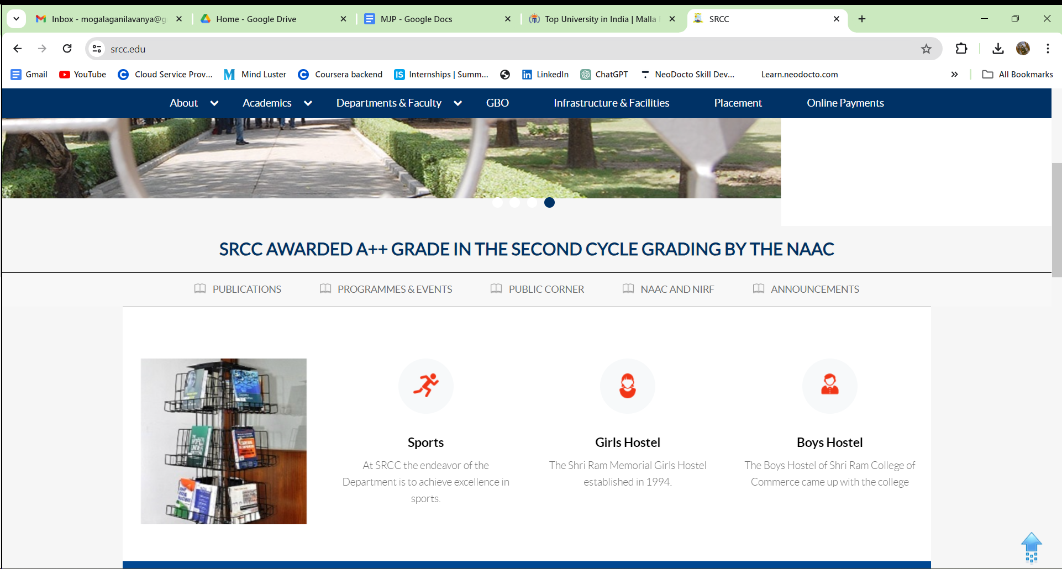

Under it

Cognizant ( picture of company it should be open and close , by clicking on it we should get information who are placed in that particular company)

TCS ( same as cognizant )

Unistring Tech sol. ( same as cognizant )

MOU ( same as cognizant )

Constable ( same as cognizant )

In **Benefits of MJPT** (full details in Handbook)

-Cosmetics(monthly 140/- for every student)

-Uniforms(2-blue uniforms, 1-white uniform every year)

-Track suit(1 pair for 3 years)

-Shoes (1 pair of shoes for 3 years)

-Examination Kit ( for every semesters )

In **MoU**

–Our college has MoU with

1. Telangana Association for Skill and Knowledge
2. HAMSA Homeopathy Hospital
3. Ethames College of Management
4. Cognizant Technology Solutions

In **IQAC**

-IQAC body

-UGC

-NIRF

-NAAC

-Meeting Minutes

-Best practices

-Feedback (parents , students & Alumni)

after tags replace all pictures with new pictures

Insert 4 slides (1 college photo , 1 Indepence day photo, 1 Karate photo, 1 Sports photo )

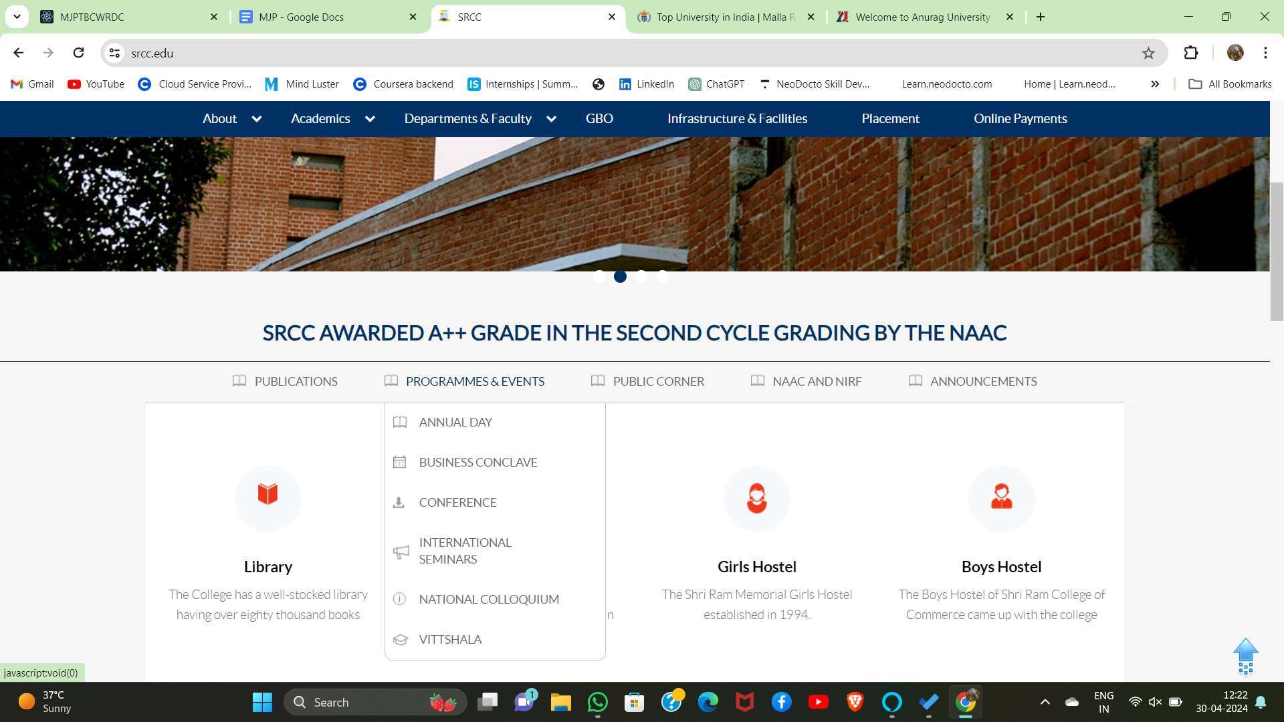

After that again insert 1) programmes and events 2) nss programs 3)computer events

In **Programmes And Events**

National Seminar ( Pictures of it, when we pointed on the picture of it should be zoom)

International Women Day (same as National seminar)

karnataka team (same as National seminar)

Annual Day (same as National seminar)

Freshers Day (same as National seminar)

In **Nss Programmes**

All programmes which are held in Library Hall (same as National seminar)

In **Computer events**

Hackathon

Cyber Security workshop

IIT

T-Hub

Computer Literacy day

Science Day projects



After slides Add 8 blocks as same as above picture

1. Library (library is picture is same as above picture)
2. Laboratory
3. Sports (Ground picture)
4. Classrooms (classroom picture)
5. Girls Hostel (Hostel picture)
6. Gym
7. Wellness center
8. Kitchen Garden

Again Add 3 slides ( 1 Saidulu Sir photo , 1 Principal sir photo, 1 Vice-principal photo)( use new pictures )

After blocks Add Explore Our Campus Facilities Your Gateway to Excellences( Keep it same, when we clicked on Learn more. Campus life should be open)

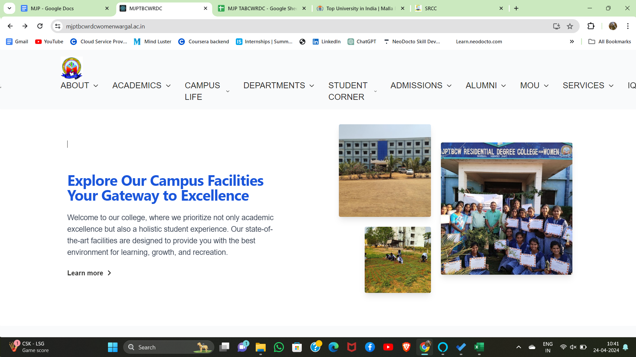

After Explore Our Campus Facilities Your Gateway to Excellences Add Welcome from principal

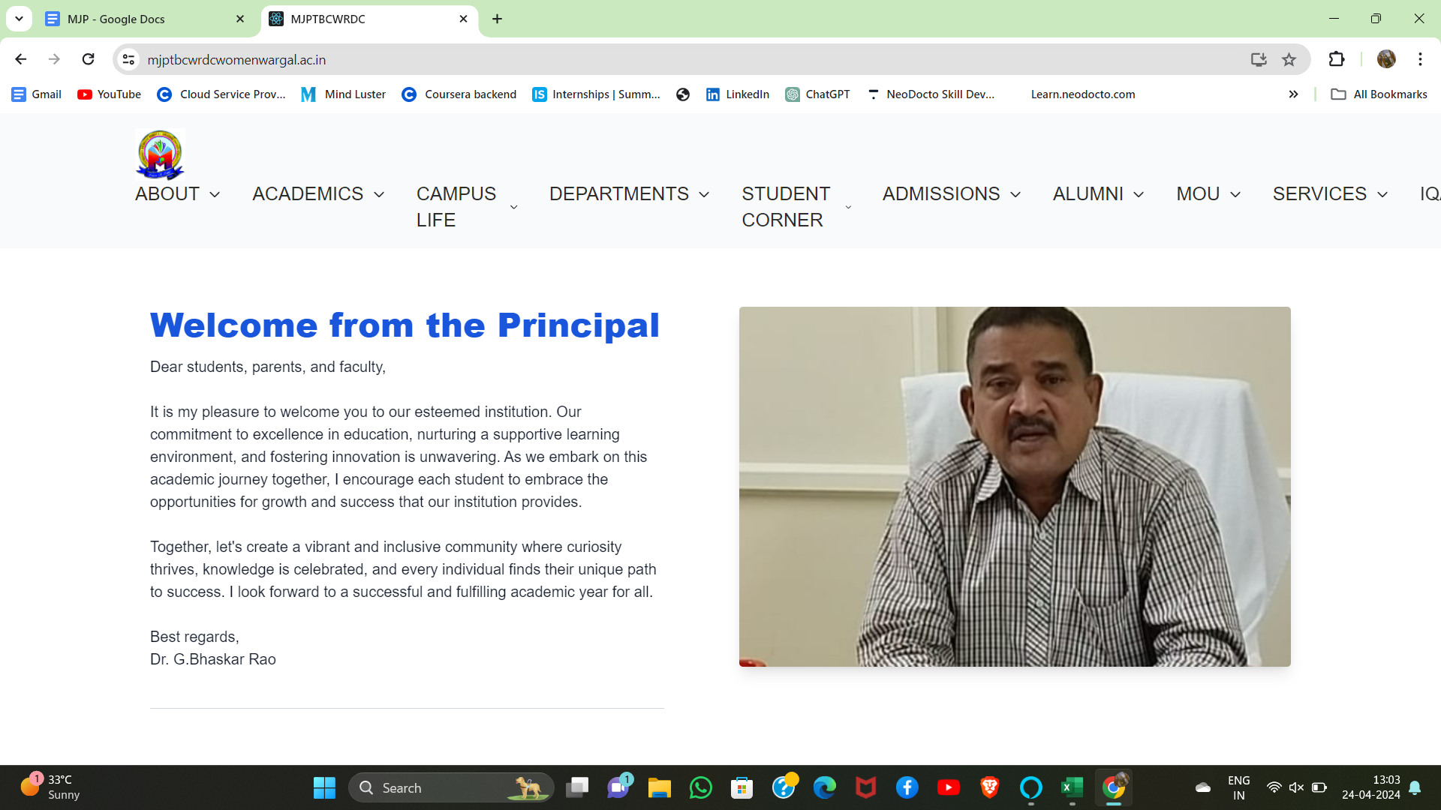

Please change principal sir photo should be good (head should not cut)

After Welcome from principal

Add

Why study at

MJPTBCWR Degree College (change this also, it should be same as below picture)

Add information about college and full picture of college(same as below image)

10,000+ bring minds from across the global,

100+ proficient instructors boasting top-tier degrees

Sports rating 98%

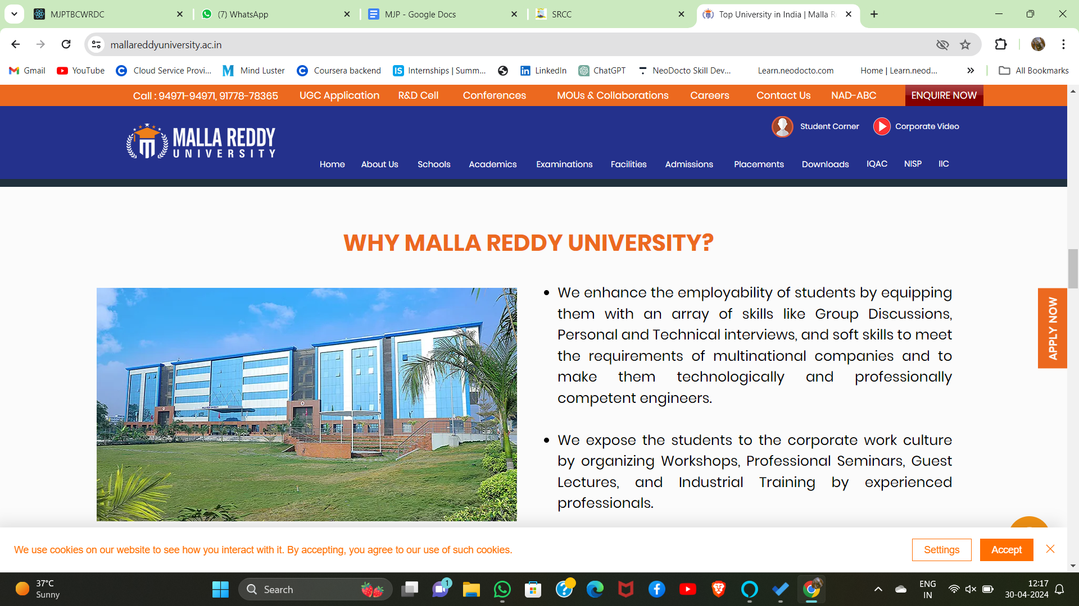

After Why study at

MJPTBCWR Degree College

Add Knowledge exploring



Add **Knowledge Exploring** in the home page(replace life at Au with **Knowledge Exploring,** replace Au with MJP, replace Anurag with MJPTBCWR, Replace university with Degree College, remain Vibrant,Inclusive. Alive)

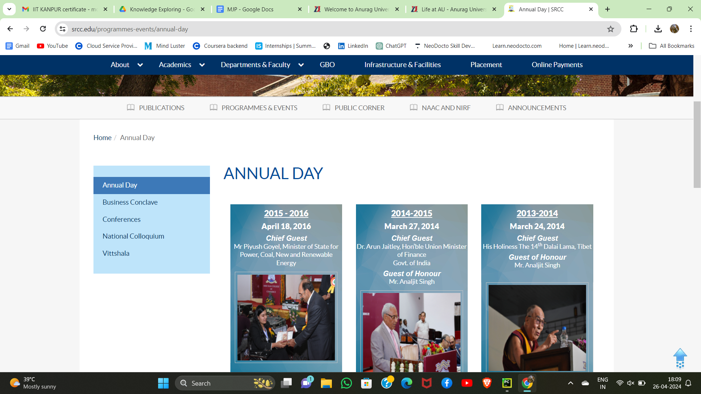

(after clicking on learn more, it should be display as above picture. Replace Annual day with Startup Maha Kumbh. One Group PIcture. And add every student picture should be display)

-**Startup Maha Kumbh** (replace annual day)(I have given all the details in MJP folder)

-**Training In IIT Kanpur** (replace conference )(Photos are in MJP PICTURE of KNOWLEDGE EXPLORING )

-**Summer Fellowship Program** (replace National colloquium)

Total 14 member (**IIT Kanpur students information**)

1.NAME : M.Lavanya

Group : III Bsc.MSDS

MENTOR : Danish

Course Name : Full Stack Web Developer

DURATION : (26 June 2023 To 15 July 2023)

2.NAME : M.Navya

Group : III Bsc.MSDS

MENTOR : Danish Sir

Course Name : Full Stack Web Developer

DURATION : (26 June 2023 To 15 July 2023)

3.NAME : V.Geetha

Group : III Bsc.MSDS

MENTOR : Jeetendar Sir

Course Name : Python For Data Science

DURATION : (26 June 2023 To 15 July 2023)

4.NAME : B.Tejaswini

Group : III B.COM (BA)

Course Name : Cyber Security

DURATION : (28 June 2023 to 15 JUly 2023)

5.NAME : M. Stuthi Keerthana

Group : III B.COM (BA)

Course Name : Cyber Security

DURATION : (28 June 2023 to 15 JUly 2023)

6.NAME : G. Swathi

Group : III B.COM (BA)

Course Name : Cyber Security

DURATION : (28 June 2023 to 15 JUly 2023)

7.NAME : V.Keerthi

Group : III B.COM (BA)

Course Name : Cyber Security

DURATION : (28 June 2023 to 15 JUly 2023)

8.NAME : S.Manisha

Group : III B.COM (BA)

Course Name : Cyber Security

DURATION : (28 June 2023 to 15 JUly 2023)

9.NAME : V.Soujanya

Group : III B.COM (BA)

Course Name : Cyber Security

DURATION : (28 June 2023 to 15 JUly 2023)

10.NAME : K.shilpa

Group : III B.COM (BA)

Course Name : Cyber Security

DURATION : (28 June 2023 to 15 JUly 2023)

11.NAME : G. Eshwaramma

Group : III B.COM (BA)

Course Name : Cyber Security

DURATION : (28 June 2023 to 15 JUly 2023)

12.NAME : G. Harini

Group : III B.COM (BA)

Course Name : Cyber Security

DURATION : (28 June 2023 to 15 JUly 2023)

13.NAME : G. Sravani

Group : III B.COM (BA)

Course Name : Cyber Security

DURATION : (28 June 2023 to 15 JUly 2023)

14.NAME : M. Anusha

Group : III B.COM (General)

Course Name : Cyber Security

DURATION : (28 June 2023 to 15 JUly 2023)

-**Summer Fellowship Program( They are 2 members ,who are already participated and another 3 member will Participated soon )**

1.NAME : Bala Varalaxmi

Group : III MPC

SUBJECT : Chemistry

INSTITUTION NAME : IISC (BENGALURU)

MENTOR : Dr.E.D Jemmis Sir

TOPIC TITLE : Understanding differences between C2H6 and B2H6

DURATION : 2 Months (25 June 2023 To 30 Aug 2023)

2.NAME : Kandli Bhoomika

Group : III Bsc.BZC

SUBJECT : Botany

INSTITUTION NAME : Madras Christian College Chennai

MENTOR : Dr. G. Gnanashekaran Sir

TOPIC TITLE : Diversity of Inflorescence,corolla types and their adaptive strategies for pollination in the plants of tropical dry evergreen forest india

DURATION : 2 Months (30 June 2023 To 31 Aug 2023)

3.NAME : Pembarthi Suchitra

Group : III Bsc.BZC

SUBJECT : Chemistry

INSTITUTION NAME : IIT Pallakad , Kerala

MENTOR : Padmesh sir

TOPIC TITLE : Molecular Orbital Theory

YEAR : 2024

4.NAME : Ediga Indhu

SUBJECT : Botany

INSTITUTION NAME : IACS Kolkata

MENTOR : Aniindita Das Sir

TOPIC TITLE : Polymer’s touch the lives of everyone

YEAR : 2024

5.NAME : Kadiyam Laliky

SUBJECT : Botany

INSTITUTION NAME : CIMAP College bengaluru

MENTOR : Dr. A. Dinesh Sir

TOPIC TITLE : Single cell protein

YEAR : 2024

after Knowledge exploring

Add **Job Training in MJP** in home page



(same as above picture with background color also same, ninf replace with Job Training, In engineering replace with Mahendra pride [no. of students attended count],Cognizant [no. of students attended count], Infosys [no. of students attended count] and Ethames [no. of students attended count])

*-Mahendra pride*

*-Cognizant*

*-Infosys*

*-Ethames*

At last Add Explore the artistic experiences at our college events

Keep it same and add this links

Free Resources for students:

Links

<https://swayam.gov.in/nc_details/NPTEL>

<https://epgp.inflibnet.ac.in/>

<https://www.aicte-india.org/opportunities/students/resources_students>

<https://ndl.iitkgp.ac.in/>

<https://www.mindluster.com/>

Add Left side of the page

Up-side allow  (when we click on the allow, we should come to Top of the page)

End the page

change slides pictures and principal sir photo also